Relationships

🌟 Definition
# Source: AI Source: Provided by: [Data Path: Persons Table -> ID Column: 1, Name_En Column: Motasem Essam] -> From: [ChatGPT] on [6/10/2026]
A Relationship is a connection or association between two or more entities.
Relationships describe how entities interact with each other in a system.

🎯 Purpose
# Source: AI Source: Provided by: [Data Path: Persons Table -> ID Column: 1, Name_En Column: Motasem Essam] -> From: [ChatGPT] on [6/10/2026]
Relationships help answer:
- How are entities connected?
- How does one entity interact with another?
- What business rules exist between entities?

🧠 Simple Example
# Source: AI Source: Provided by: [Data Path: Persons Table -> ID Column: 1, Name_En Column: Motasem Essam] -> From: [ChatGPT] on [6/10/2026]
Entities
Customer
Order
Relationship
A Customer places Orders
Diagram:
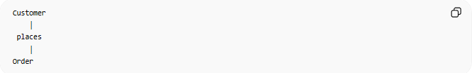
Customer
│
places
│
Order

📚 Real-World Examples
# Source: AI Source: Provided by: [Data Path: Persons Table -> ID Column: 1, Name_En Column: Motasem Essam] -> From: [ChatGPT] on [6/10/2026]
Online Store
Customer places Order
School System
Student enrolls in Course
Hospital System
Doctor treats Patient
Banking System
Customer owns Account

🔢 Types of Relationships

1. One-to-One (1:1)
# Source: AI Source: Provided by: [Data Path: Persons Table -> ID Column: 1, Name_En Column: Motasem Essam] -> From: [ChatGPT] on [6/10/2026]
Meaning
One record in Entity A is related to exactly one record in Entity B.
Example:
Person ───── Passport
A person has one passport.
A passport belongs to one person.

Diagram
Person 1 ───── 1 Passport

Example Table
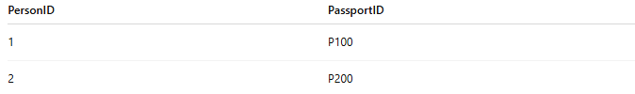
PersonID | PassportID
1 | P100
2 | P200

2. One-to-Many (1:N)
# Source: AI Source: Provided by: [Data Path: Persons Table -> ID Column: 1, Name_En Column: Motasem Essam] -> From: [ChatGPT] on [6/10/2026]
Meaning
One record in Entity A can be related to many records in Entity B.
Example:
Customer ───── Orders
One customer can place many orders.
Each order belongs to one customer.

Diagram
Customer 1 ───── N Orders

Example
CustomerID | Name
1 | Ali
Orders:
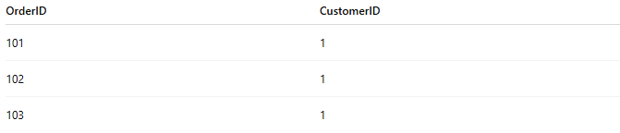
OrderID | CustomerID
101 | 1
102 | 1
103 | 1
Ali has multiple orders.

3. Many-to-Many (M:N)
# Source: AI Source: Provided by: [Data Path: Persons Table -> ID Column: 1, Name_En Column: Motasem Essam] -> From: [ChatGPT] on [6/10/2026]
Meaning
Many records in Entity A can be related to many records in Entity B.
Example:
Students ───── Courses
A student can enroll in many courses.
A course can contain many students.

Diagram
Students M ───── N Courses

Example
Student:
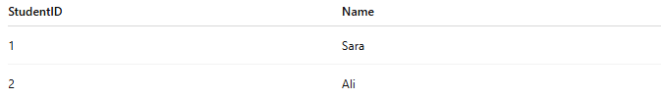
StudentID | Name
1 | Sara
2 | Ali
Course:
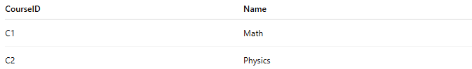
CourseID | Name
C1 | Math
C2 | Physics
Enrollment:
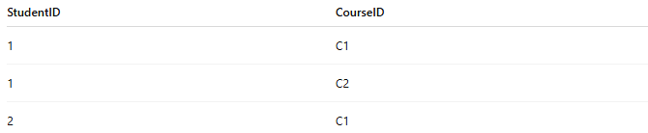
StudentID | CourseID
1 | C1
1 | C2
2 | C1

🗄️ Relationships in Databases
# Source: AI Source: Provided by: [Data Path: Persons Table -> ID Column: 1, Name_En Column: Motasem Essam] -> From: [ChatGPT] on [6/10/2026]
Relationships are usually implemented using Foreign Keys.

Customers Table
CustomerID | Name
1 | Ali

Orders Table
OrderID | CustomerID
101 | 1
Here:
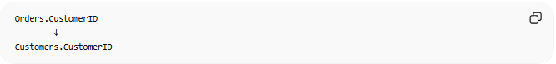
Orders.CustomerID
↓
Customers.CustomerID
The foreign key creates the relationship.

📊 ER Diagram Representation
# Source: AI Source: Provided by: [Data Path: Persons Table -> ID Column: 1, Name_En Column: Motasem Essam] -> From: [ChatGPT] on [6/10/2026]
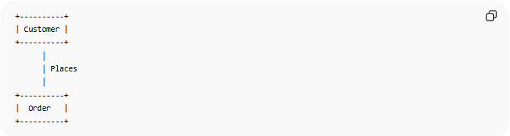
+----------+
| Customer |
+----------+
│
│ Places
│
+----------+
| Order |
+----------+

🔗 Common Relationship Examples
# Source: AI Source: Provided by: [Data Path: Persons Table -> ID Column: 1, Name_En Column: Motasem Essam] -> From: [ChatGPT] on [6/10/2026]
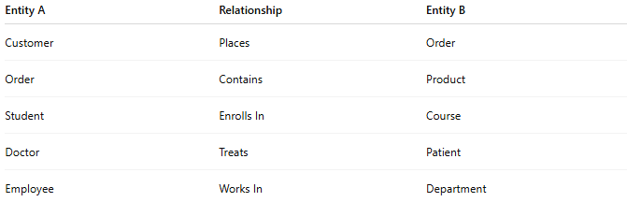
Entity A | Relationship | Entity B
Customer | Places | Order
Order | Contains | Product
Student | Enrolls In | Course
Doctor | Treats | Patient
Employee | Works In | Department

⚠️ Relationship vs Entity
# Source: AI Source: Provided by: [Data Path: Persons Table -> ID Column: 1, Name_En Column: Motasem Essam] -> From: [ChatGPT] on [6/10/2026]
Entity
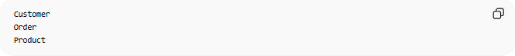
Customer
Order
Product
Represents things.

Relationship
Customer places Order
Order contains Product
Represents connections between things.

🌍 Online Store Example
# Source: AI Source: Provided by: [Data Path: Persons Table -> ID Column: 1, Name_En Column: Motasem Essam] -> From: [ChatGPT] on [6/10/2026]
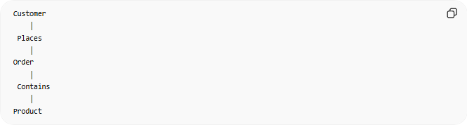
Customer
│
Places
│
Order
│
Contains
│
Product
Entities:
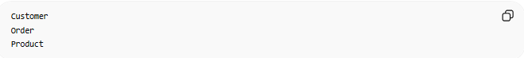
Customer
Order
Product
Relationships:
Places
Contains

🧠 Simple Analogy
# Source: AI Source: Provided by: [Data Path: Persons Table -> ID Column: 1, Name_En Column: Motasem Essam] -> From: [ChatGPT] on [6/10/2026]
Think of entities as people in a social network.
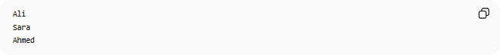
Ali
Sara
Ahmed
The relationship is the connection between them:
Ali ── Friend Of ── Sara
Sara ── Works With ── Ahmed
The people are entities; the connections are relationships.

🧭 Summary
# Source: AI Source: Provided by: [Data Path: Persons Table -> ID Column: 1, Name_En Column: Motasem Essam] -> From: [ChatGPT] on [6/10/2026]
A Relationship is a connection between entities that describes how they interact with one another. Common relationship types are One-to-One (1:1), One-to-Many (1:N), and Many-to-Many (M:N). In relational databases, relationships are typically implemented using foreign keys.

